Name These Serra Mesa Businesses
Business #1
Business #2

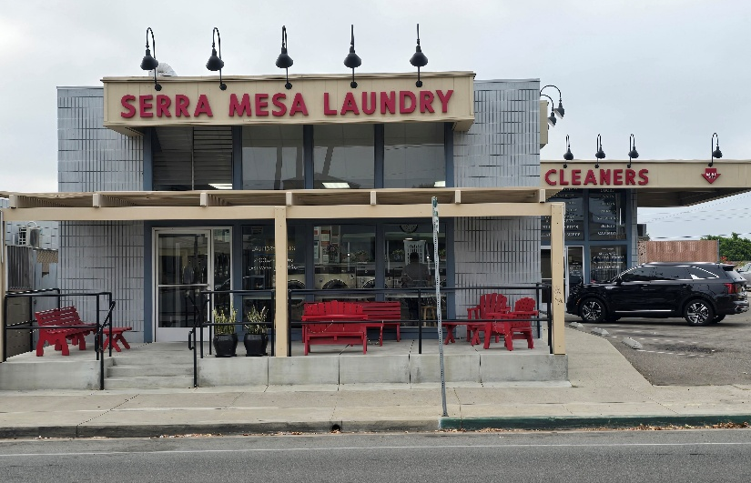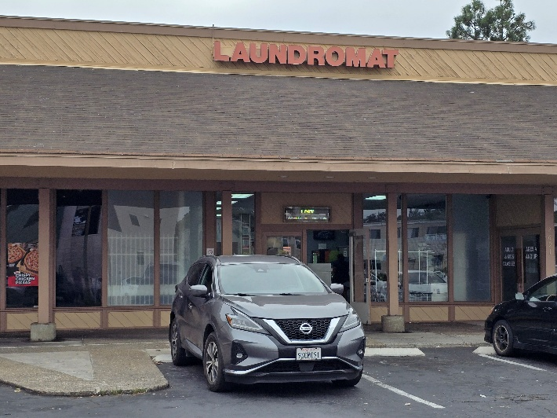
Business #4
Business #3
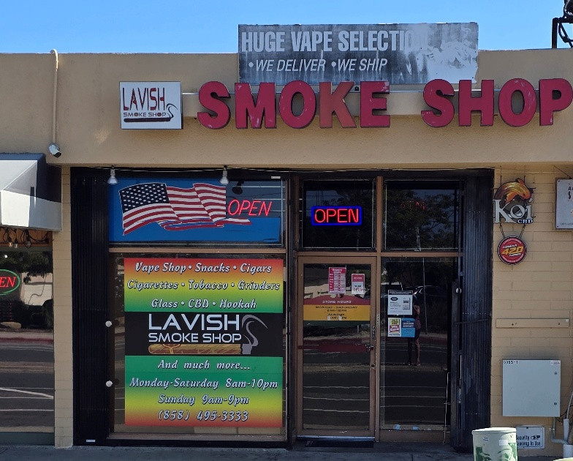
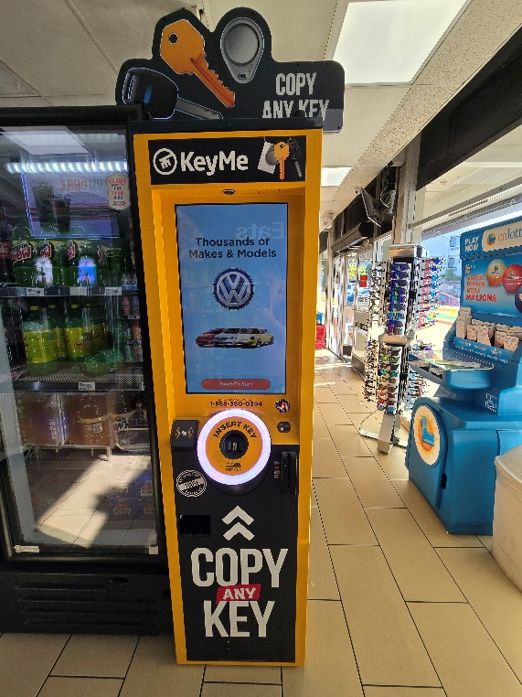
Business #5

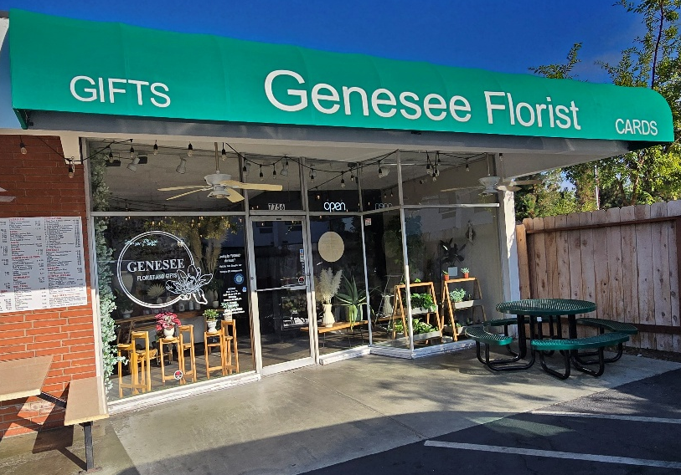

S | Y | R | S | R | E | L | C | R | D
L | E | N | D | N | A | E | Y | & | Y
V | A | R | U | A | L | E | G | D | R
I | H | S | V | L | L | A | N | U | A
S | K | O | M | I | I | V | N | A | L
E | S | H | K | E | C | O | I | S | E
P | O | L | E | M | Y | E | S | M | A
K | C | O | E | E | F | L | S | S | R
S | M | I | E | S | O | I | T | I | R
H | T | G | E | N | R | S | M | S | E

Brain Teaser Answers
Observer
Nov/Dec 2025

Clue – Services (Red)
Location #1 – Serra Mesa Laundry & Dry Cleaners
3263 Greyling Dr (Gold)
Location #2 – Mission Village Laundry
2693 Mission Village Dr (Purple)
Location #3 – Lavish Smoke Shop
3355 Sandrock (Green)
Location #4 – KeyMeLocksmith 7750 Starling, inside 7-11 (Blue)
Location #5 – Genesee Florist 7756 Starling (Brown)

